**Documentation Tool: Sphinx**

1. **Introduction:**

Sphinx is an open-source documentation generation tool that helps create and maintain high-quality documentation for software projects, libraries, APIs, and other text-based documentation requirements. It was originally developed for documenting Python projects but has since expanded to support multiple programming languages including Java. Sphinx generates documentation in various formats such as HTML, PDF, LaTeX, and ePub from source files written in reStructuredText or Markdown.

1. **Documentation:**

To view the overview of Sphinx, click [here](https://www.sphinx-doc.org/en/master/).

1. **Installation and Usage:**
   1. ***How to install Sphinx?***

Click [here](https://youtu.be/jyrfgwhOmNQ?si=cv__IFCQufHVgW_M)

* 1. ***How to make Sphinx documentation?***

Click [here](https://youtu.be/BWIrhgCAae0?si=IF3Lw3EwHoqGI_at)

* 1. ***Source Code***

Here are the source codes of one python files the we’ve created: addition

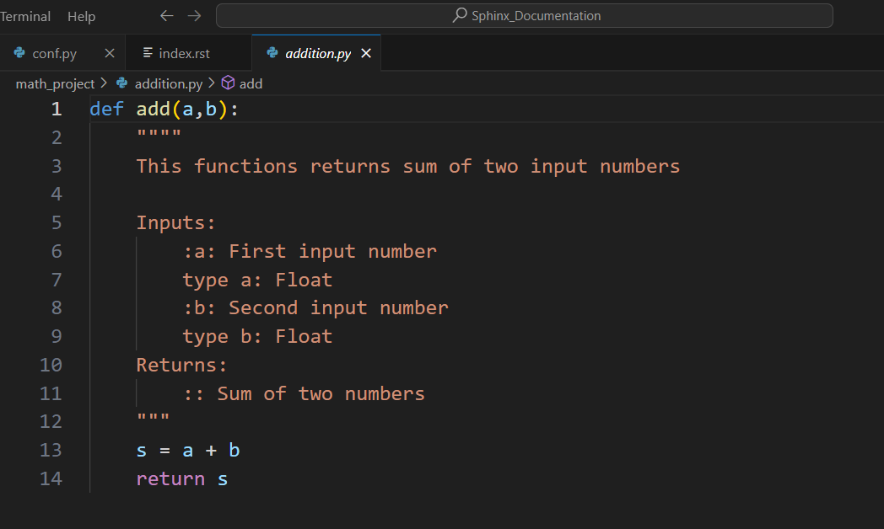

* 1. ***Produce Documentation***

Here is the documentation created for those python files.

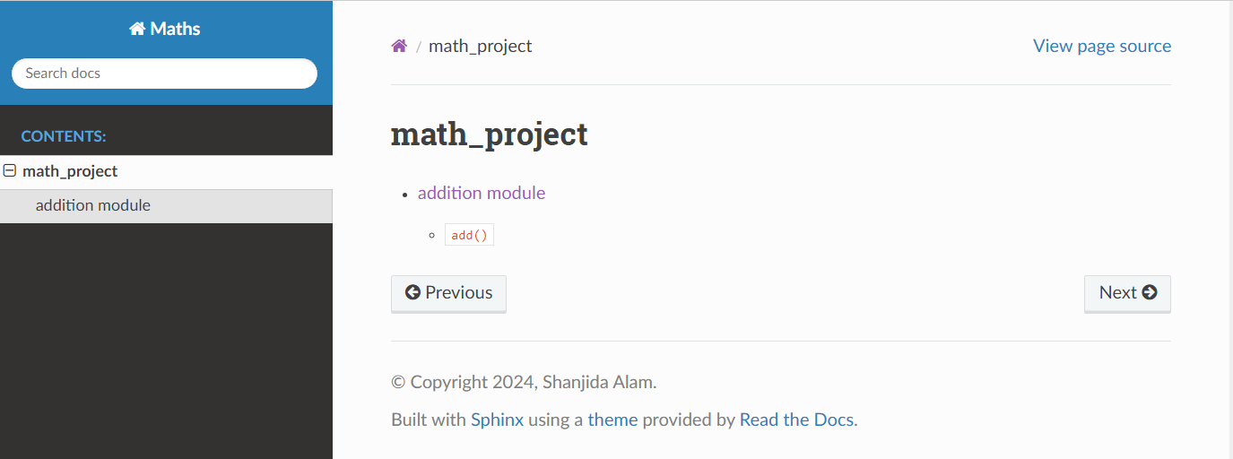

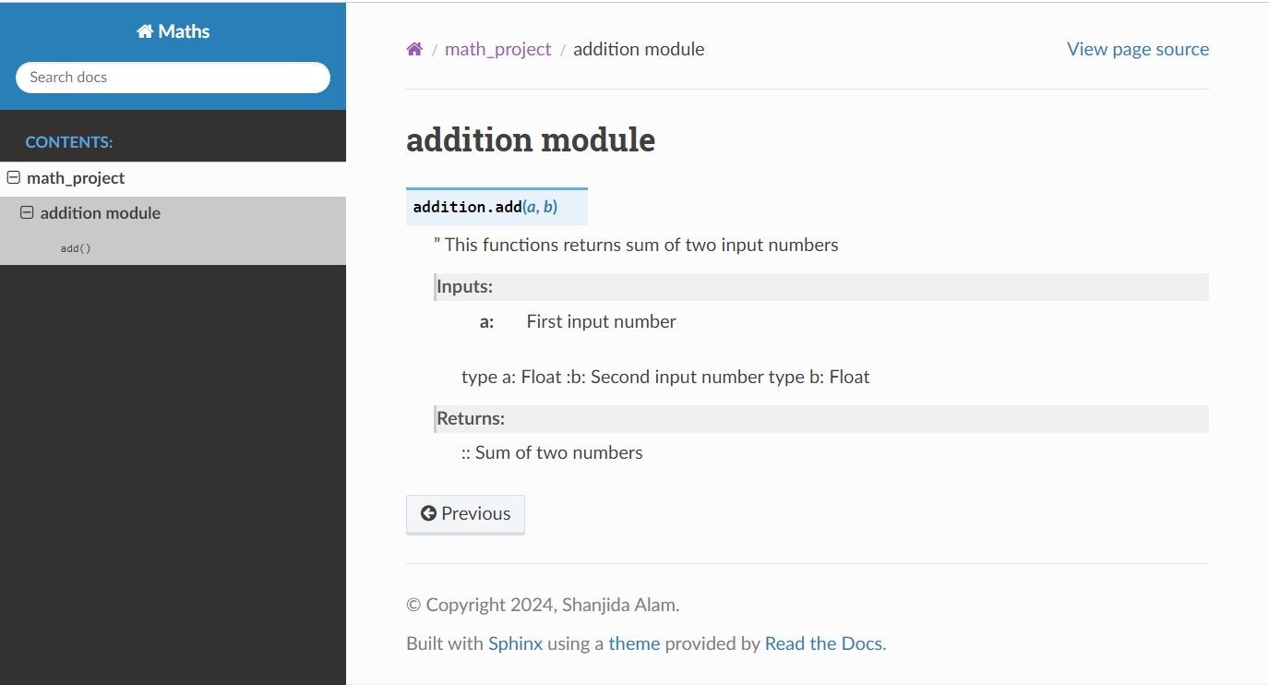

1. **Pros & Cons of Sphinx**

1.Why Sphinx?

* Markup language support
* Automatic document generation
* Extensibility
* Cross-referencing and indexing
* Multiple output formats
* Integration with version control systems

2. Why not Sphinx?

* Mastering the syntaxes and understanding the configuration options can take time for beginners.
* Complex for simple projects.
* Integration with non-python projects might require additional effort or workarounds.

Despite these limitations, Sphinx remains a powerful and widely used documentation tool in the

software development community.